**Project Description**

Eurofins work-planner

**Supervisors**

Mona Wendel Andersen

Michael Viuff

**Authors**

Kenneth Jensen

Jimmi C. B.

Teakosheen Joulak

Florin Bordei

# Background Description

Eurofins is an international network of laboratories, centered in the European countries. Their Danish office is located in Vejen, and its focus is to test food, dairy products and feed. (Eurofins Scientific, 2018)

Today, they have multiple excel-sheets for keeping track of their calendar, work assignments and vacations. The excel-sheets are updated manually for each employee by their team leader. In that sense, the team-leader organizes the work-load of each employee for the upcoming weeks, using a separate work-sheet, to have the right amount of people on each task. They keep another document to keep track of preferences, for example allergies, bad shoulder and so on. The team leaders need to keep track of whether an employee can perform a certain analysis (if they have been trained for it). (Eurofins Steins)

The problem with the manual input of all the calendars where the team leaders juggle between 3 worksheets, is that they often make mistakes and the process consumes a lot of time. The mis-assignment of a resource will influence other projects, because of the inter-connectivity of projects and departments in modern organizations. It is therefore vital that team leaders establish an appropriate sequence and configuration of work, which is difficult to do manually. (Bendoly, Perry-Smith, & Bachrach, 2010)

Eurofins needs an application that can store a staff time template, a training sheet and a work plan in one place. They would like to be able to edit these, even when others are viewing them, and they want only team-leaders to be able to edit the files. The different functions need to be flexible to allow for comments, adding or removing different analyses, hiring new employees and hiding or removing old ones. They would like to able to store the data for at least a year and they want to be able to view the plan without installing the application, for example online.

Eurofins has some extra wishes, that are not necessary, but would be appreciated by them. These include keeping their color coding, adding a possibility to search for a specific employee or analysis, online tool to edit and view at home, notification system when edits have been made to an employee’s schedule, a button to go to the current date and mail-groups with everyone who are trained in a specific analysis. (Eurofins Steins)

# Definition of purpose

The purpose is to create a tool that functions as a calendar, work-scheduling and resource management system.

# Problem Statement

The project focus is to create a tool that can output, create, update and edit a calendar and work-schedule that will update for each employee when a team leader update it. The tool can keep and maintain a list of employee training, work assignments and preferences. The tool can also keep lists of analyses and the required manpower for each.

Questions to be answered are the following:

* How to create multiple calendars, that are synchronized?
* How to keep track of employee training and display it?
* How to make the system maintainable, i.e. relatively easy to include new data, such as new employees?
* How to make data available for presentation?

# Delimitation

* Client/System architecture will not be created and as such there will be no off-site edit or viewing.
* Limited availability of the client.
* There will be no notification system.
* Data will not be able to be saved for longer periods of time.

# Choice of model and methods

|  |  |  |
| --- | --- | --- |
| What  Partial problem | Why  Why study this problem? | Which  Which models/theories are expected to be used to solve this problem |
| How to create multiple, synchronized calendars | Main feature of the program |  |
| How to keep track of and display employee training | Important factor in making the work-sheet |  |
| How to make the system maintainable | To be able to enter or remove employees |  |
| How to make data available for presentation | To be able to visually show our calendars |  |

# Time schedule

The expected time scope for the group is 550 hours, divided over 15 weeks, as shown in the Gantt chart below.

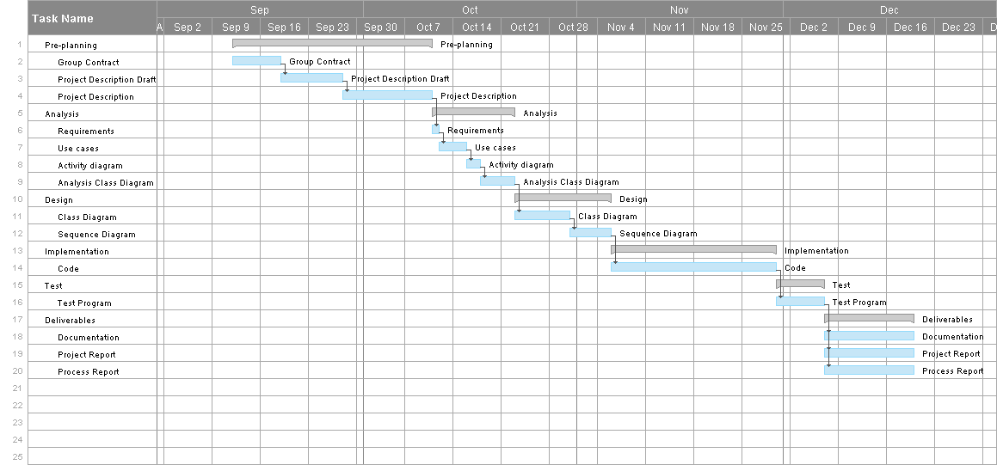

This was made using Smartsheet. The project started 12/9/18 and the final deadline is 19/12/18. We have estimated the length of the phases and these are subject to change, but out estimations are, that analysis will last a week, design will last 2 weeks, implementation will last 4 weeks, with the last one and a half week being used split between implementation, testing and finishing our project and process report. (Smartsheet, 2018)

# Risk assessment

|  |  |  |  |  |  |  |  |
| --- | --- | --- | --- | --- | --- | --- | --- |
| Risks | Description | Likelihood  Scale: 1-5 | Severity Scale: 1-5 | Product of Likelihood and Severity | Risk mitigation | Identifiers | Responsible |
| Risk 1 | Lack of time before hand-in | 4 | 4 | 16 | Stick to our Gantt chart, keep time management | Stress  Making excuses  Bad mood | Teakocheen |
| Risk 2 | Lack of communication during/before work-time | 5 | 3 | 15 | Ask for the AWOL member in group chat, help assign them in github | One or member members out of contact | Kenneth |

# Sources of Information

Bendoly, E., Perry-Smith, J. E., & Bachrach, D. G. (2010). The perception of difficulty in project-work planning and its impact on resource sharing. *Journal of Operations Management*, 385-386.

Eurofins Scientific. (2018, August 10). *Food and Feed testing: Eurofins Scientific*. Retrieved from Eurofins Scientific: https://www.eurofins.com/food-and-feed-testing/

Eurofins Steins. (n.d.). Retrieved from Itslearning: http://ict-engineering.dk/Course/SEP1-A18/WorkPlanToolPresentation.pdf

Gaddis, T. (2007). *Starting out with Java* (5th ed.). Essex: Pearson.

ICT Engineering. (2012). *Project Description guidelines.* Retrieved from Studienet: https://studienet.via.dk/projects/Engineering__project_methodology/General/Guidelines/2018%20Project%20Description%20(Appendix%201)%20VIA%20Engineering%20Guidelines.pdf

ICT Engineering. (2012). *Project report guidelines.* Retrieved from Studienet: https://studienet.via.dk/projects/Engineering__project_methodology/General/Guidelines/2018%20Semester%20and%20Bachelor%20Projects%20-%20VIA%20Engineering%20Guidelines.pdf

ICT Engineering. (2018, August). *Semester and Bachelor Project guidelines.* Retrieved from studienet: https://studienet.via.dk/projects/Engineering__project_methodology/General/Guidelines/2018%20Semester%20and%20Bachelor%20Projects%20-%20VIA%20Engineering%20Guidelines.pdf

Smartsheet. (2018). *Smartsheet*. Retrieved from https://app.smartsheet.com/b/publish?EQBCT=ea6daac9e3c246f48858de201cd777ac